Functional connectivity dynamics differentiate subdivisions of precuneus

- Hypothesis
The whole brain functional connectivity of each subdivision of the precuneus will change over time, alternating between a finite number of “micro-states”. We propose that each subdivisions will posses a distinct microstate profile (e.g., number of states, state features, state-shifting pattern, duration of states).

B. Analysis procedures
1. Preprocessing
Chao-gan has preprocessed the first 5 min of session 1 and session 2 data for all 25 subjects.
The data we are going to use are: HeadMotionRegression_2Friston_24_COV_GloabalWS (motion corrected with Friston 24, global signal regressed out. W: normalized, S: smoothed).

2. ROI Time series extraction
a. Seed location selection
Four representative seeds reported in Margulius et al. (2009) were selected for the current study:
Seed 4 (-2/-36/35): Located in the middle of the splenium in the y-axis, within the cingulate gyrus.
Seed 6 (-2/-47/58): Located at the center of the marginal ramus of the cingulate sulcus, 6 mm posterior to it.
Seed 14 (-2/-64/45): Located ventral to seed 13 along the sulcus.
Seed 17 (-1/-78/43): Located ~10 mm posterior to seed 13 and 6 mm anterior to the parietal-occipital sulcus.
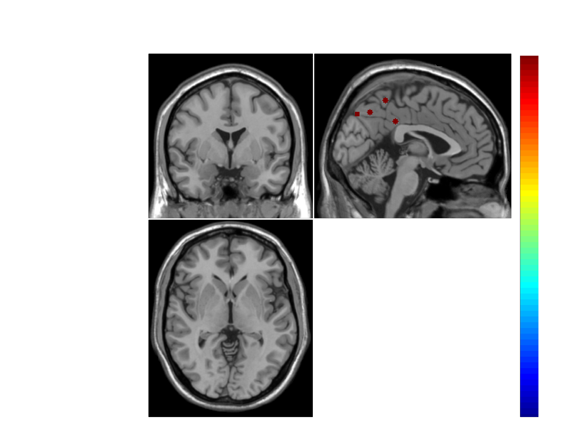

b. ROI atlas selection:
We selected the functional atlas (i.e. Crad-200) instead of anatomic atlas because the microstate clustering was based on functional connectivity and an atlas with functionally independent ROIs was desired.
c. ROI mask creation
22 ROIs in Crad-200 were removed due to overlapping with precuneous and PCC which were identified according to the Harvard-Oxford atlas, leaving a total of 178 ROIs for final analysis.
d.Time series extraction:
Time series of each voxel was z-score normalized before ROI time series extraction to minimize possible bias in subsequent variance-based data reduction steps.
The time series of 4 seeds and 177 ROIs were extracted from the preprocessed 4D timeseries data in MNI space.
These time series were then concatenated to form a 450 x (4+177) matrix A.

3. Stationary FC analysis using the full length of the time series
Correlation Analysis
- Perform the correlation analysis on matrix A (181x181).
- Extract the full correlation for each seed and saved in Matrix B (4 x 177)
- Fisher transform the correlation matrix C (4 x177).
- Sort connections based upon lobar (i.e., frontal, temporal, parietal, occipital, subcortical) classifications into matrix D.
- Plot the stationary FC for each seed
Covariance analysis

4. Dynamic FC estimation using time series within a sliding window:
Sliding window creation
- The window created by convolving a rectangle and a Gaussian window (sigma=3 TRs) (Allen, et al., 2012) with the following two sets of parameters:
- width = 0.645 s *69 TRs= 44.5s, slide in steps of 3 Trs=1.9s, N_win= floor((N_vol-W_width)/step)+1=128;
- width=0.645s *22TRs=14.2s, slide in steps of 1 TR=0.645s, N_win=429
Left: time series; Right: frequency responses
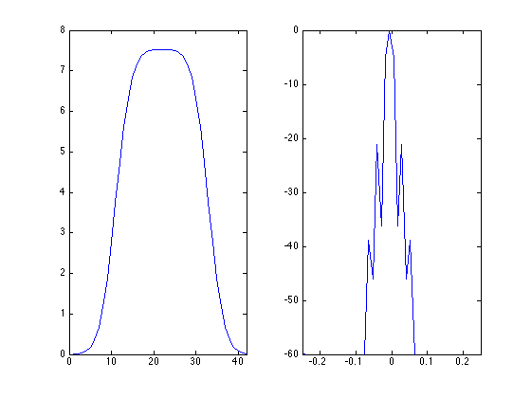

FC analysis for each sliding window
Apply the sliding window to matrix A which contains the time series of 4 seeds and 177 ROIs, resulting a three dimensional matrix F (W_width x ROI x N_win: 69/22 x 181 x 128/429). Description below will use W_width=69TR as an example.
- Perform the correlation analysis on each window in matrix F and get a correlation matrix G: 181x181x128. Extract the first 4 rows and the columns corresponding to the 177 ROIs from the correlation matrix and get a 4x177x128 (seed x ROI x N_win) matrix H.
- Fisher transform matrix H and get a z score matrix I.
- Plot examplar dynamic FC windows in r and Z based on matrix E and F respectively.
- plot the time course of dynamic FC based on matrix F (each time point corresponding to the center of the window)
- plot the power spectral for the time courses plotted in d
FC state identification using clustering analysis: subsampling/initial clustering/secondary
clustering
FC state can be defined as highly structured patterns of FC that emerge and dissolve over tens of seconds (Allen et al., 2012).
a. Exemplar selection: compute the FC variance for each seed and each window, resulting a 4x128 matrix containing the variance data. The windows with local maximum variance were selected as the exemplar window for each seed.
b. For each seed, put the exemplar windows in one matrix
c. initial clustering: apply K-means clustering algorithm to the set of exemplars from all subjects to obtain the group centroids. The number of clusters was determined using the elbow criterion of the cluster validity index, computed as the ratio between within-cluster distance to between-cluster distance. Repeat this clustering for 500 times to increase the chances of escaping local minima.
d. Second clustering: all windows were
included in the second clustering, the group centroids computed from the initial clustering were used as the initial solution for this single clustering run.The centroids of a cluster putatively reflects a connectivity state stably present within the data.
e. Estimate the network modularity of each state by using the Louvain algorithm implemented in the Brain Connectivity Toolbox (This algorithm doesn't apply to our data as it only applies to square matrix)
f. compute the Markov Chain state transition matrix (TM) and plot it. The average transition probability matrix was computed by averaging across all subjects. Approximate the stationary probability vector (pie) as the principal eigenvector of the TM, which represents the expected behavior of the system in the long run. Plot the TM and pie.
6. Compare the number, feature, and duration of states among the 4 seeds
7. Calculate the test-retest reliability of the state analysis. This can be quantified as intra-class correlations on state measures between the data collected in session 1 and session 2.

